
Effective – August 1, 2010

1. Intent:

Intent: The intention of these rules is to provide a class of scratch-built Sports Car slot cars reflecting the cars used in the 1966 Rod & Custom racing series. This was the first pro racing series that featured all the southern California factory team racers from Russkit, Checkpoint and Cox etc battling it out for national magazine exposure and glory.
These are the cars that lit the scratch building fire for most of the retro racers today. The innocence of design, scale and simplicity and the dream they brought of one day being as good as Mike Steube, Tore Anderson, Bryan Warmack, John Cukras, Terry Schmid or Mike Morrissey.
Remember that your build must be in the spirit of the 1966 “Rod & Custom” magazine racing series. The chassis must reflect the ones shown in the race reports in the pages of the magazine, published all over the Internet. Forget the technology you have learned in the past 43 years, R&C SC has no place for it.
This class is meant as a fun, 1966 technology based class, not a “lets see how fast we can go” “why can’t I do this, the cars will be faster” racing class. The cars are fun to build, detail and drive.
Chassis will not use any design elements, materials or technologies that were not used in the 1966 R&C series. The governing body reserves the right to disallow any design that is not in the correct spirit and make technical changes as it is seen fit to keep the class pure.
2. Dimensional Specifications

2a. Maximum Overall Chassis Width: 3” (measured across any part of the chassis)
2b. 1/8” axles front and rear.
2c. Rear Tires: .935” min. dia. x .500” max. width.
2d. Front tires: .875” min. dia. x .200” min. width.
2e. Minimum Clearance: 0.063” (measured under the whole chassis including gear except for the guide flag). All clearances measured with car standing on a flat tech board on its wheels, without guide.
2f: Maximum ready to race weight limit is 130 grams. The adding of lead or the round brass style weights used in the 1960’s will be limited to the drop arm only. No lead or brass weights may be added to the chassis in any other place.
2g. 3” Maximum tire track width. Tires may extend pass the body in rear to get width. Front tires must be under body at all time.
2h. 3.25” Maximum body width as measured over the wheel arches.
3. Chassis Construction
3a. Construction is to be a spaced rail, Jail Door style chassis.
3b. A maximum of 5 main rails on each side of the drop arm. (“5-railer”). No more than two (2) rails may be side-by-side and soldered together. There must be a space of at least .063 between any joined rail(s) and the next rail(s).
3c.No tapering (or bending of the rails except for the bend up to bracket or axle tube) of the rails, only parallel rails from the front to the rear connecting the axles.
3d. All rails do not have to bend up to the axle but must run from motor bracket to center of front axle.
3e. A 5th outer rail can have the rear portion of the rail tapered and attached to the adjacent rail and/or rear axle tube.
This allows a chassis to have 5 rails without interfering with rear tires.
3f. A maximum of 2 outrigger body mount rails. Both rails have to be straight and parallel with no bends.
3g. Drop arm must only be made from B/B tubing or rod and must use a piece of 7/32” brass tubing to hold the guide or the machined brass guide holders/bushing like that made by R-Geo and shown in the photos. Flat brass tongues like used on D3 or IRRA Can-Am chassis are not allowed to be soldered to the top of the drop arm rails.
Drop arm may be no wider than ¾”.
A single piece of B/B is allowed to bend out around guide to act as a stop as shown in the picture above.
Drop arm must be made of B/B rod. Drop arm must be a single layer of B/B high, no stacking of rails on top of each other to make drop arm heavier. The rails must connect to and support the guide tube/bushing.
Drop arm may be straight or tapered front to back.
Drop arm may use a modern or period guide held in place with a nut or screw and washer.
Hinge must be made of 3/32 brass tubing (3 piece). Piano wire is allowed to be used inside the brass tubing.
Drop arm must drop and function as intended by the 1966 designs.
Lead wire holders are not allowed.

3h. A piano wire U-brace may be used inside the motor bracket to reinforce the bracket and protect the crown gear.
3i. No floating body mounts of any kind.
3j. No hypoid motor brackets. Motor may not be closer than .550” to the center of the rear axle. Motor may slant down to the .062” ground clearance at the motor can brush end.
3k. Motor bracket maybe no wider than 1” and no thicker than .047”.
3l. No tying of axles or any other joint allowed. Rails cannot be wrapped around axle tubes.

Proper use of so-called half-rails or reinforcement bracing:
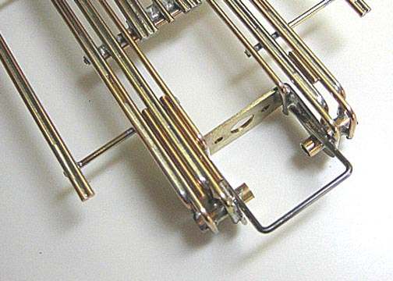 |  | As shown here on either side of this sample chassis, the “half-rails” (on the left side) or a piece of brass rod (at right) are not allowed.

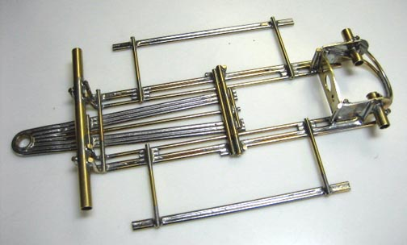 |  | The next two pictures show an additional rail soldered to the face of the mounting bracket, and bent at 90-degree towards the BACK of the chassis. This is legal but only ONE rail can be added per side.

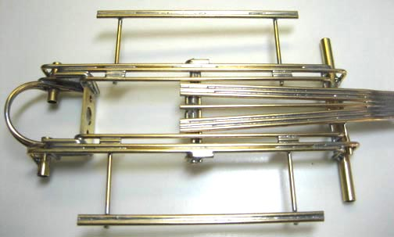 |  | The small pieces of brass rod right below the body mounting pin tubing are legal as long as they do not exceed .3” in length. Drop arm can be built straight (with parallel rails) or tapered as shown here. Note that the “L” braces on the drop arm hinge are legal if no longer than .3” in their total length seen from above.
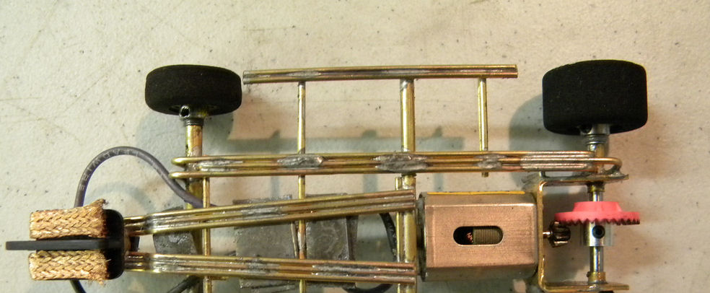
No more than two (2) rails may be side-by-side and soldered together. There must be a space of at least .063 bwtween any joined rail(s) and the next rail)s. Also, only 3/32 tubing is allowed for the drop arm hinge. This construction is not legal.
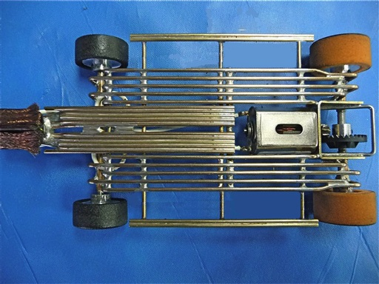
A 5th outer rail can have the rear portion of the rail tapered and attached to the adjacent rail and/or rear axle tube.
This allows a chassis to have 5 rails without interfering with rear tires.

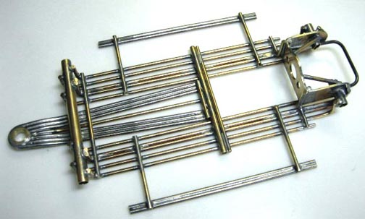
As shown here, a single 90-degree brass-rod piece per side soldered perpendicularly to the main rails from the motor bracket is legal.

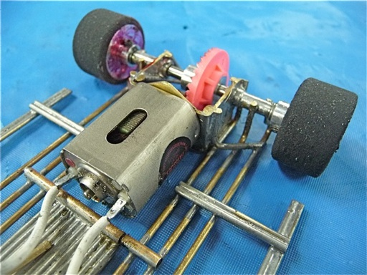
90 degree “L” brace shown at left is not allowed. “L” brace must be “perpendicular” as shown in example above.

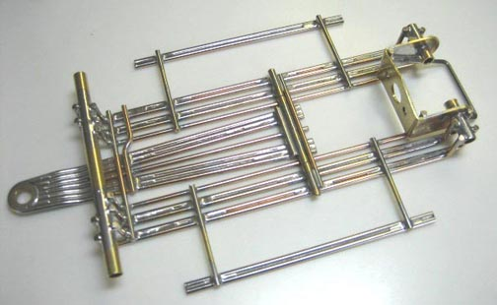  4. Chassis Materials |  | This frame is 100% in the spirit of the rules and a good example of what to build.
4a. Only 1/16” brass tubing, rod or bronze rod can be used.
4b. No steel-wire main rails. No steel-wire front axle braces. Steel wire can only be used as a brace to reinforce the motor bracket as described in Par 3a.
4c. Only brass tubing for axles and body mounts can be used.
4d. No brass strips or plate allowed to brace or add weight to the motor bracket.
4e. Brass tubing or rod drop arm only. No brass strip or plate is allowed. A bushing or tubing may be used as a guide pivot.
4f. Drop arm must be a single layer of brass rod. You may not stack brass rod to make drop arm heavier.
4g. No bat-pans or side pans.
4h. No ball bearings. No axle bushings. Tubing front and rear axle carriers only.
4i. Up to 1/8th” side to side movement (known as the “Cukras Slop”) of the front axle in the tube is ok.
4j. A modern or period guide may be used and attached with a guide nit or a screw.

5. Motor rule:

5a. Motor type: Unopened, unmodified TSR T3215, Falcon 1 or Falcon 2 motors. Motors must be shown at tech inspection in a manner to clearly show the acid mark on their cans.

5b. Clear violation of motor-tampering rule will result in permanent exclusion from any R&C participation in any form.

5c. Motor must be affixed to motor bracket with two screws set inside the pre-tapped locations on the can.
Motors can also be soldered in.

5d. Local areas may elect to use a hand-out motor system for a particular race. The management of the process will be up to the local race director.

6. Body rules
6a. Body style: Open cockpit sports racers only. Bodies must be originals or close reproductions of pre-1967 Sports Racers by Russkit, Lancer, Associated, Dynamic etc. No “flattened” or “aerodynamically improved” bodies allowed.
6b. Bodies with molded-in cockpits are not allowed even if cut out.
6c. Front wheel arches must be cut out. Rear wheel arches may be left closed if the original full-size car ran with closed wheel arches.
6d. Bodies must be presentably painted and carry at least three racing numbers, one on each side, and one on the front.
6e. No part of the chassis may be seen when looking at the car from its top. Vents can be cut on body to match actual air intakes/exhausts on the 1/1 car.
6f. Bodies must be molded from material with a minimum thickness of 10 thousandths of an inch.
6g. Some of the approved bodies listed as well as others are too narrow to cover the tires when the full width of the chassis is being used. It is OK for the tires to show past the fenders as long as any part of the car does not exceed a width of 3”.
6h. Spoilers and air control: Rod &Custom Series and Car Model Series spoilers are legal. Must be clear or painted plastic. Can be no wider than the body and no more than 5/8” high and must be flat (no additional bends).
6i. Front Diaplanes: The maximum visible size is 3” x ½”. It cannot be attached to the top of the body. It must be integrated into the front portion of the body.
6j. Cockpits must be fully opened following the natural line of the windscreen and the body. A separate, presentably and realistically painted 3-D driver figure and interior must be fitted.
6h. Approved bodies: Note – as additional bodies are approved they will be communicated.

Truescale:
Dynamic Lotus-40
Dynamic Lola T-70.

O/S:
Lola T70
Lotus 40
Electric Dreams:
Russkit Lotus 40
Dynamic Lotus 40
Dynamic Lola T70
Russkit Chaparral 2
Russkit McLaren MK2

John Dilworth Bodies:
Lotus 40 McLaren M1B
Dubro Lola T-70
McLaren M1A
Hussein I

Tom Anderson Bodies:
All pre-1967 Sport Cars

Other bodies must be submitted to the R&C Committee members for approval. In any case or dispute as of the legality of any given car to participate in the Series races, the Series Director or Director Delegate’s decision will be final.
Any matter regarding this class must be submitted in writing to the R&C Committee.

Examples of car for this class
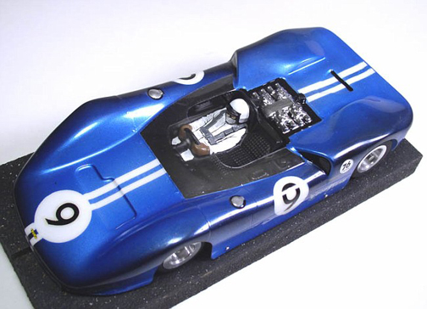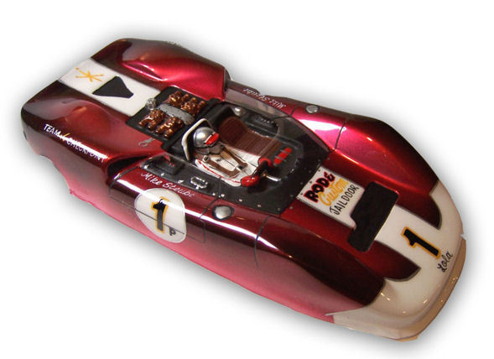

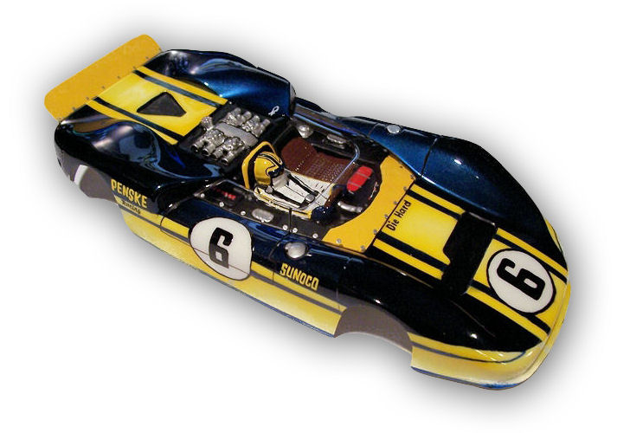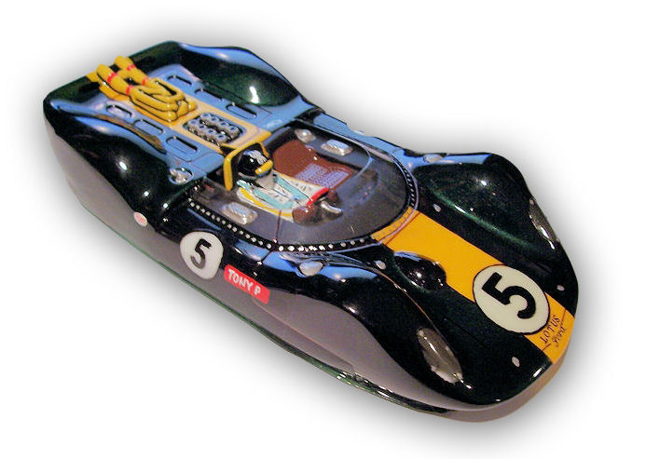

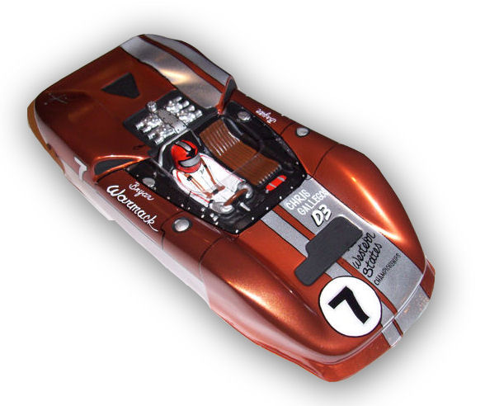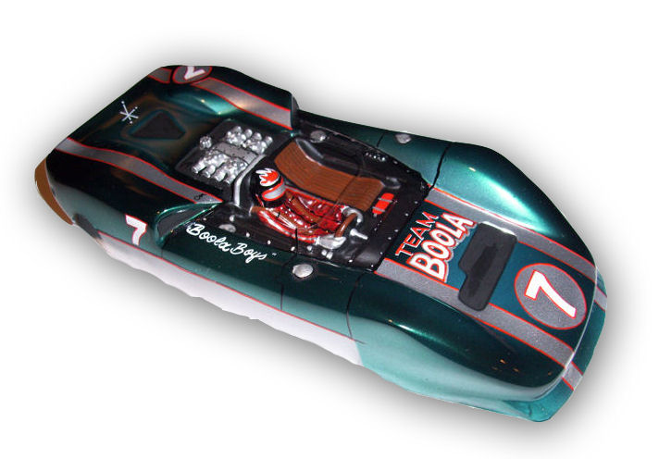

(Photos courtesy Jairus Watson Joe “Noose” Neumeister)

